Multimedia report- CW1

To gain feedback and create an accurate report for the website I created using atom I made a questionnaire and sent it to some of my peers to get their unfiltered opinion of my work. It is also important to note that the questionnaire was filled out completely anonymous so that when answering these questions people could be as critical as possible.

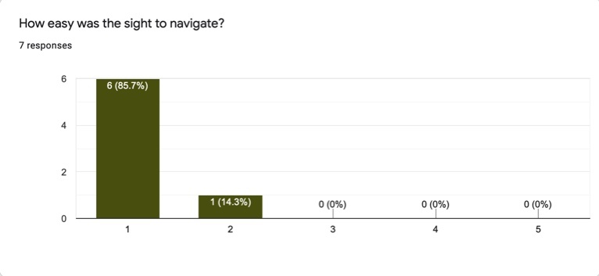

My first question as shown above was “How easy was the site to navigate?” and the results were that six out of the seven people (85.7%) that were asked selected number one which means “very easy to navigate”. Nevertheless one out of the seven people asked said it was slightly less easy to navigate and if I were to create this questionnaire again I would add in a section where my peers could explain their answers which would give me some more in depth feedback and I would know how to improve the navigation of the site. From the feedback I think a way to improve the navigation of the site would be to have the words in the menu bar above slightly bigger so that it may be easier to see for a viewer to see, an alternative to this would be to change the colour of the menu bar to also make it more visible.

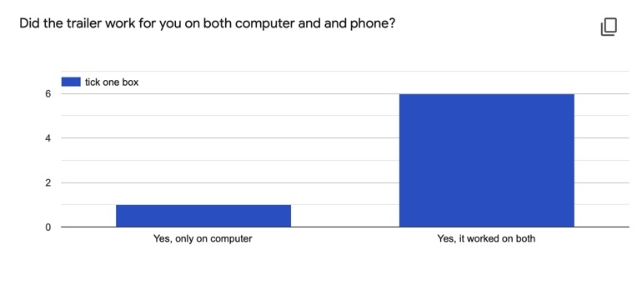 Question two as shown above was “Did the trailer work for you on both computer and phone?” and the results were that again six out of the seven people said that it worked on both whereas one person said that it only worked on their computer. There was two other options you could choose to answer this question which were “Yes, only on phone” and “No, it didn’t work on either”, these options haven’t shown up on the graph because these were never selected. If I were to make this website again I would double check that the format was correct to view the trailer on both phone and computer as for one person it didn’t work.

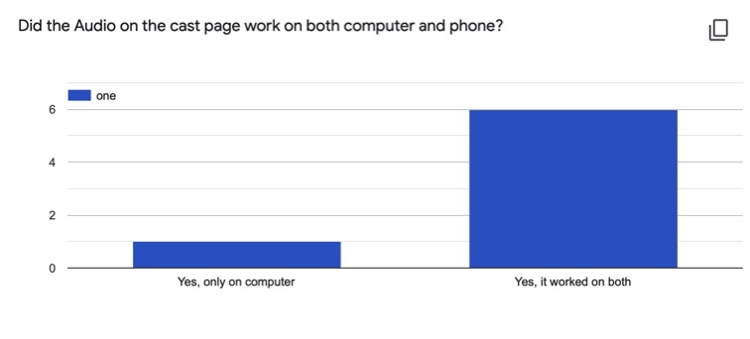

The Third question as shown above was “Did the audio on the cast page work on both computer and phone?” which is almost identical to the second as shown above was also to check if the audio worked for the viewers of the site too in which six out of the seven people said it did and one person disagreed which I can only assume was the same person as on the previous question. Again if I were to make this website again I would double check that the format was correct to view the trailer on both phone and computer as for one person it didn’t work.

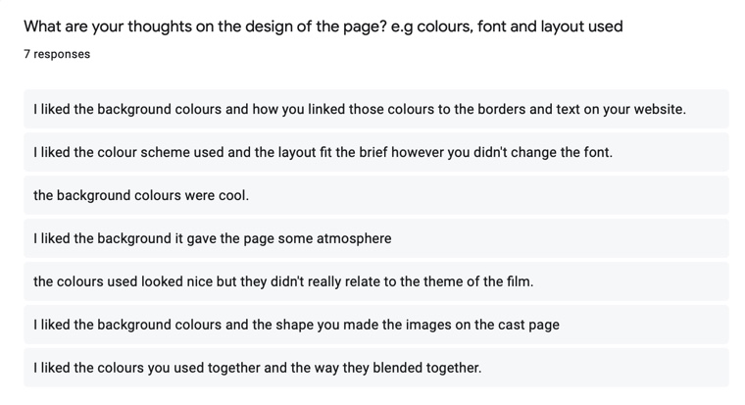

The fourth question as shown above was “What are your thoughts on the design of the page? e.g. colours, font and layout used?” the majority of people who answered said that they liked something to do with the colours used in the background or just the colour theme in general which I could agree with on my design. Alternatively two out of the seven peopled asked gave constructive criticism back, one person said that “ the colours used looked nice but they didn’t really relate to the theme of the film” which I can agree with as 1917 is a war film however I based the colours I used on what happens at the end of the film when the war is over which may not be clear from just viewing the page. From this feedback if I was to make this website again, I would make the colours used a bit darker and more relatable to the themes in the film.

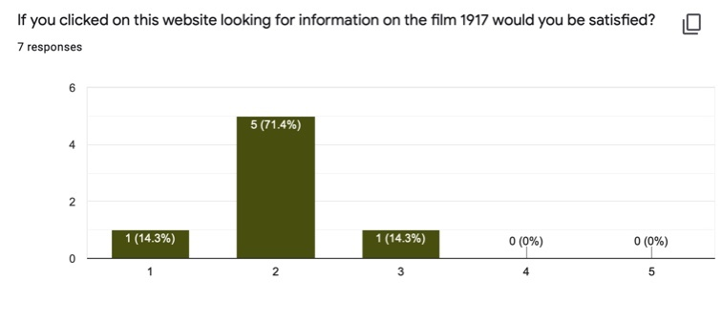

The fifth question as shown above was “If you clicked on this website looking for information on the film 1917 would you be satisfied?” and the results were that 14.3% of people asked (one person) would be highly satisfied however the other six people clicked two or lower on how satisfied they would be. I assume that this would be because the website doesn’t have much information about the movie itself and more on the cast and behind the scenes therefore if you were looking for information about what happens in 1917 you would be less satisfied. Therefore from this feedback if I were to create this website again I would add more writing and information about the what happens in the film and less about behind the scenes therefore improving the content.

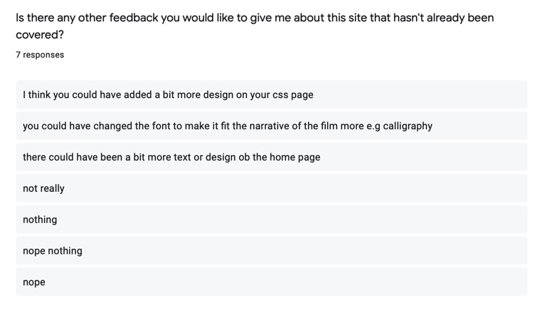

Finally, my last question as shown above to get any more constructive criticism other than from the questions I asked myself. The question was “Is there any other feedback you would like to give me about this site that hasn’t already been covered?” four out of the seven people asked said there was no more feedback they needed to give back however 3 people did. Two of the participants said that they thoughts I could have added a bit more design into my home page which it did look a bit empty however I was just following the layout sheet on the other hand if I was to create my webpage again I would add more design to the home page by adding borders around images and text and also by adding more relevant images.

Another person said that I could have changed the font to fit the narrative more clearly which I would assume she means using more outdated font which they would have used to write in the 1910s such as calligraphy. I agree that this font would fit in with the theme on 1917 better however this is a website and I think that font would make the writing harder to read therefore I would not change the font if I were to do this next time.

To conclude my evaluation, I would take on board most of the constructive criticism given to me by my peers to improve my website in the future.